Customer Churn Prediction Using Machine Learning

Customer churn is an important business problem for subscription-based companies because losing customers reduces recurring revenue and creates the need to acquire replacement customers. The purpose of this project was to determine whether machine-learning techniques could be used to identify customers who are at increased risk of cancelling their subscription. This project used the Telco Customer Churn dataset, which contains customer demographic, account, service, and billing information. The dataset contains 7,043 customer records and 21 variables, with customer churn serving as the target variable.

Customer retention is an important consideration for subscription-based businesses. When a customer ends their subscription, the company loses the recurring revenue associated with that customer and may need to spend additional resources to acquire a replacement customer. Because of this, identifying customers who may be considering cancelling their service can provide an opportunity for businesses to intervene before the customer leaves. Machine-learning classification models provide a potential way to identify patterns in historical customer data that are associated with churn. Rather than treating all customers as having the same level of risk, a predictive model can estimate which customers are more likely to churn based on characteristics of their accounts and services.

Can historical customer demographic, account, service, and billing information be used to predict which customers are most likely to churn? This project aims to analyze these factors and identify patterns that may indicate a higher likelihood of customer churn. The goal is not simply to predict whether an individual customer will churn, but to provide actionable insights that businesses can use to better understand their customers. Ultimately, the project seeks to help businesses prioritize customer-retention efforts by identifying customers who may be at most risk of leaving.
This project relates to four key business questions that are related to customer churn and retention. First, it focuses on which customer characteristics are associated with customer churn, using factors like demographic, account, service, and billing information that may indicate a higher likelihood of leaving. Second, it asked if the machine-learning models can accurately predict whether customers will leave or remain with a service. Third, the analysis determines which of the evaluated models provides the strongest predictive performance by comparing their results using appropriate performance metrics. Finally, the project looks at whether the model’s results can be used to come up with a customer retention strategy. Together, these questions connect the analytical results to practical business decisions and provide a framework for using predictive modeling to reduce customer churn.
Each row in the dataset represents an individual customer, while each column describes a characteristic of that customer. The available information includes demographic characteristics, customer tenure, subscribed services, contract type, payment method, monthly charges, total charges, and whether the customer ultimately churned.
This bar chart shows the distribution of customers by churn status. It highlights that most customers have not churned, while a smaller proportion have churned:
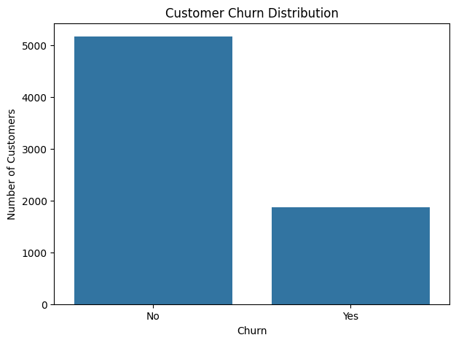
This distribution demonstrates that churn is a substantial minority outcome rather than the typical customer outcome. However, the imbalance also needs to be considered when evaluating machine-learning models. Accuracy alone may not provide a complete picture of model performance because a model could achieve relatively high accuracy by correctly predicting the larger group of customers who do not churn while failing to identify customers who do churn.
An important data-quality issue was identified in the TotalCharges variable. Although the initial null-value check did not identify missing values, further inspection revealed that some observations contained blank strings. These blanks were converted to missing values, resulting in 11 missing observations. Because these observations represented less than 0.2% of the dataset, the affected rows were removed rather than imputed.
Our target variable was churn, and we converted into a binary classification target, where customers who did not churn were represented by 0 and customers who churned were represented by 1. The dataset contains a large number of categorical variables, including contract type, internet service, payment method, and customer-service features. Because machine-learning classification algorithms require numerical inputs, categorical variables were converted into numerical dummy variables. Numerical variables were standardized so that variables measured on different scales could be used consistently by the machine-learning models. Finally, the prepared dataset was divided into training and testing subsets using an 80/20 split. The training data was used to develop the models, while the test data was held out for evaluating how well the models performed on previously unseen customers.
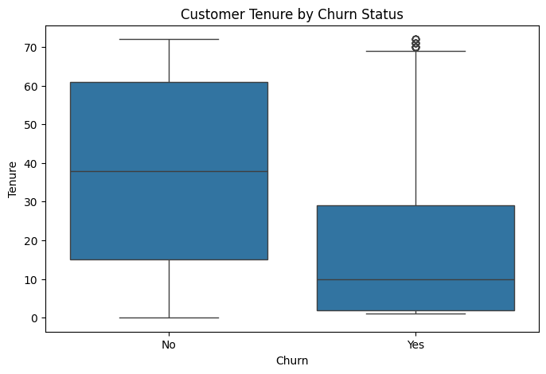
Figure 2 compares customer tenure between customers who churned and customers who remained with the company. The distribution in the chart indicates that customers who churned generally had shorter tenures than customers who remained. This suggests that the length of the customer relationship may be associated with churn behavior. From a business perspective, this is important because newer customers may represent a particularly valuable target for retention efforts. This relationship does not demonstrate that short tenure causes churn. Instead, it identifies tenure as a potentially useful predictor that can be evaluated further through predictive modeling.
Our exploratory data analysis soon identified several customer characteristics that appear to be associated with customer churn. However, examining the remaining variables doesn’t give us the complete prediction of customer behavior given the multiple characteristics we have. Machine learning was therefore used to evaluate whether the combination of customer demographic, account, service, and billing characteristics could be used to predict churn.
The Logistic Regression model was used as an interpretable classification model and provided a baseline against which the other models could be compared. An important advantage for this project is that Logistic Regression provides coefficients that can help explain how individual features contribute to the model's predictions.
The Random Forest model was selected as an ensemble tree-based model capable of capturing nonlinear relationships between customer characteristics and churn. It also provides feature-importance scores that can be used to investigate which variables contributed most strongly to predictions.
The Gradient Boosting model was evaluated as a second tree-based ensemble approach. Rather than building independent trees, Gradient Boosting builds models sequentially, with later models attempting to improve upon previous errors.
In each model we looked at several factors, accuracy: the percentage of all customers the model classified correctly, precision: the customers the model predicted would churn versus the percentage who actually churned, recall: of the customers who actually churned this is the percentage the model successfully identified, F1-Score: the combined measure of precision and recall and the ROC-AUC: the measure of how well the model distinguishes customers who churn from customers who remain across different classification thresholds.
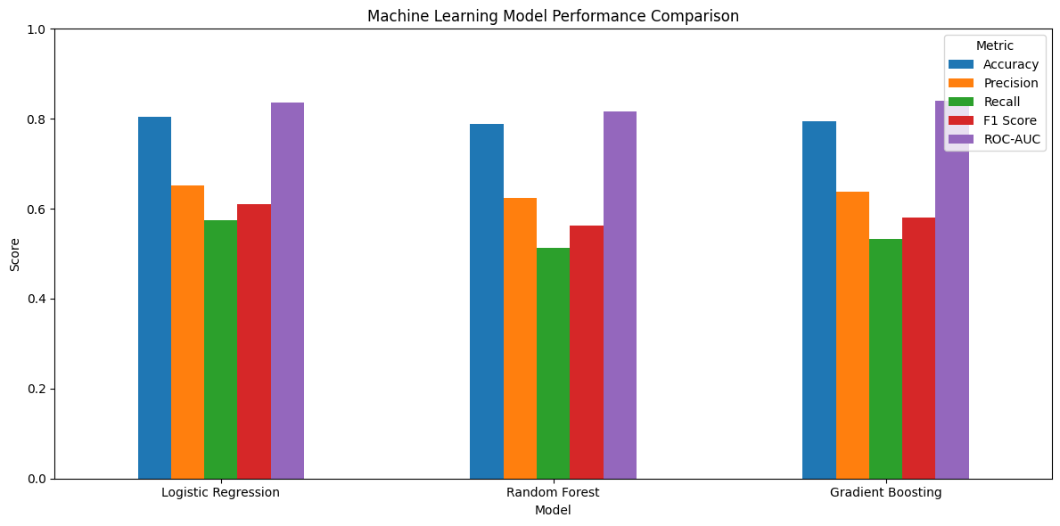
Figure 3 compares the performance of the three classification models across the five-evaluation metrics with Logistic Regression produced the strongest reported results across all five metrics. It achieved an accuracy of 80.38%, precision of 64.94%, recall of 56.95%, F1-score of 60.68%, and ROC-AUC of 83.61% while Random Forest produced an accuracy of 78.32% and ROC-AUC of 81.98%, and Gradient Boosting produced an accuracy of 79.18% and ROC-AUC of 82.00%. Because of this Logistic Regression performed better across the reported evaluation metrics, it was selected as the final model.
Logistic Regression also provides an important interpretability advantage. Because the model produces coefficients for individual predictors, its results can be examined to understand which customer characteristics contribute most strongly to the model's churn predictions.
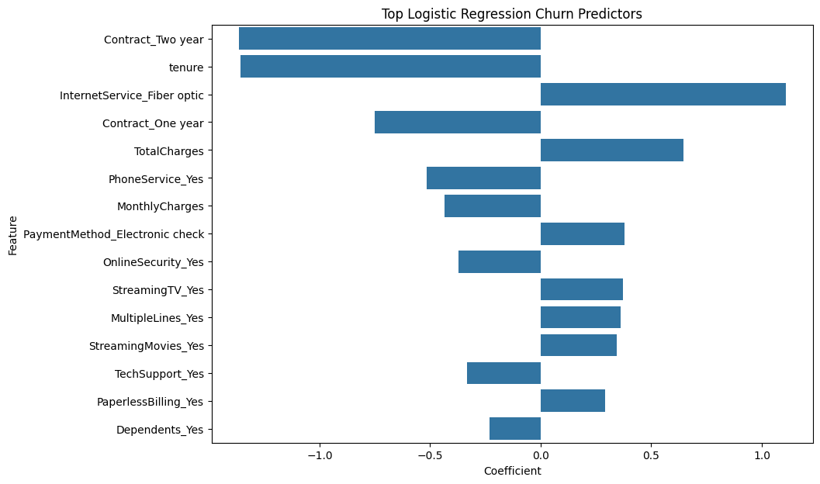

Figure 4 shows which customer characteristics that had the greatest influence on the Logistic Regression model's predictions. The model identified several billing, tenure, contract, and service-related variables as important predictors of churn. These results suggest that churn prediction is not driven by a single customer characteristic. Instead, the model uses a combination of customer tenure, billing behavior, contract characteristics, and subscribed services when estimating churn risk.
The purpose of the model is not simply to achieve a high predictive score. The larger objective is to provide information that can support better customer-retention decisions. Tenure was identified as an important predictor of churn, and the exploratory analysis showed that customers who churned generally had shorter tenures. This suggests that early customer engagement should be an important component of the retention strategy. Monthly and total charges were important predictors in the modeling results. This suggests that the relationship between pricing, service usage, and perceived customer value deserves additional investigation. Internet service, online security, and technical support also appeared among the important predictors. These characteristics may provide opportunities for more targeted customer-service or retention strategies.
Based on the analysis we have gleaned from the dataset, we can make the following recommendations to several companies:
- Companies should prioritize customer engagement during the early stages of the customer relationship.
- Rather than applying the same retention strategy to every customer, businesses could use the Logistic Regression model to assign customers a predicted churn risk and prioritize customers with higher predicted risk for intervention.
- Because billing and service characteristics were among the important predictors, businesses should investigate whether customers with certain combinations of monthly charges and services experience lower perceived value.
However, because of our dataset and what we are looking at, there are several limitations to our project:
- The model was trained using historical customer data so future customer behavior may differ from the patterns represented in the dataset.
- The model identifies predictive relationships but does not demonstrate that individual customer characteristics cause churn.
- The model does not identify every customer who churns. The recall of 56.95% means that a substantial portion of actual churners were not identified by the model.
- The dataset does not include every factor that could influence customer behavior, such as satisfaction, customer-service interactions, complaints, or other behavioral information.
This project investigated whether machine learning could predict customer churn using demographic, account, service, and billing data. Exploratory analysis found that approximately 26.5% of customers churned, with noticeable differences in tenure between churned and retained customers. Our three models: Logistic Regression, Random Forest, and Gradient Boosting were evaluated, with Logistic Regression achieving the strongest reported performance: 80.38% accuracy, 64.94% precision, 56.95% recall, 60.68% F1-score, and 83.61% ROC-AUC. The model identified tenure, billing characteristics, and service-related variables as important churn predictors, providing a foundation for targeted customer-retention strategies. The key opportunity is to use churn predictions to take action before customers leave. By identifying high-risk customers, the business can prioritize retention efforts, focus on newer customers, and evaluate pricing and service strategies to improve customer retention.

